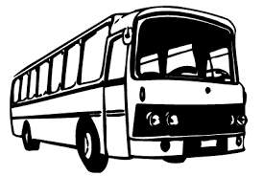

Transport (Staff/Students) - Narahenpita

- Driver : Gayan
- Tel : 0763569609
- Vehicle : ND 9708 (TATA)
- Departure/Morning : 7.00AM from Narahenpita
- Arrival : 8.30AM to IIHS
- Departure/Evening : From IIHS 5.35PM drop at 6.30PM Narahenpita
Route

Dehiwala
Contact Ashani for quarries-0768046060
Kalubowila

Nugegoda

Army Hospital

Narahenpita

Baseline Road

Peliyagoda

Wattala

Mabole

Welisara

