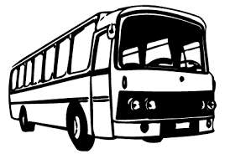

Transport (Staff/Students) - Kadawatha

- Driver : Rajanayake
- Tel : 0774449472
- Vehicle : NC 3882 (Toyota)
- Departure/Morning : 7.45 am (Makola)
- Arrival : 8.30 am (IIHS)
- Departure/Evening : 5.30 pm (IIHS)

Route

Kirithbathgoda

Kadawatha

Ragama

IIHS

Contact Ashani for quarries-0768046060

